实验报告（第一次上机）

**学号：**202030310175  **姓名：**张宴硕  **班级：**自2002

实验一：

代码：

#include<iostream>

//#include<cstring>

#include<cmath>

using namespace std;

class complex {

private:

double real;

double image;

public:

complex(double real1=0 ,double image1=0):real(real1),image(image1){}

friend complex operator*(complex& x, complex& y);

void show();

};

void complex::show()

{

cout << "The multiplication of the complexes is : " << endl;

cout << real;

if (image > 0)

cout << "+";

if(image!=0)

cout << image << "i" << endl;

}

complex operator*(complex& x, complex& y)

{

complex temp;

temp.real = x.real * y.real;

temp.image = x.image * y.image;

return temp;

}

int main()

{

double x1, x2, y1, y2;

cout << "Please input the first complex: " << endl;

cin >> x1 >> y1;

cout << "Pease input the second complex: " << endl;

cin >> x2 >> y2;

complex a(x1 ,y1);

complex b(x2, y2);

complex c;

c = a * b;

c.show();

return 0;

}

图片：  
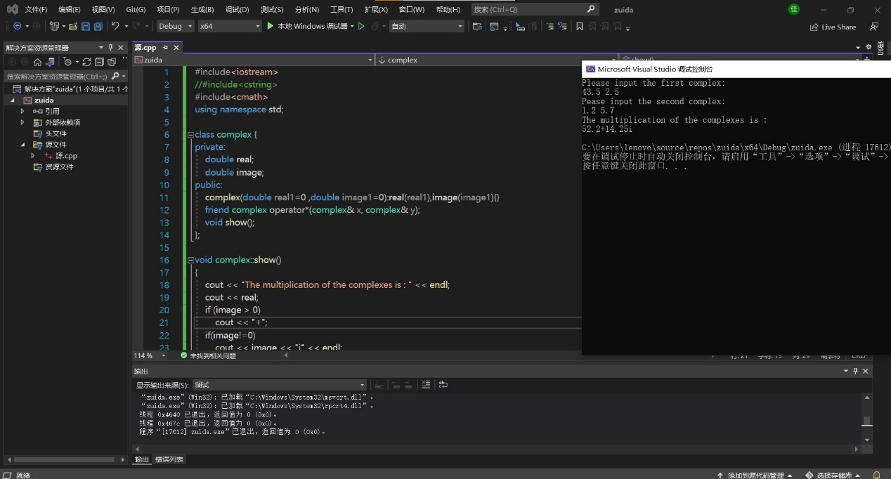

实验二：

代码：

#include<iostream>

//#include<cstring>

#include<cmath>

using namespace std;

class complex {

private:

double real;

double image;

public:

complex(double real1=0 ,double image1=0):real(real1),image(image1){}

friend complex operator*(complex& x, complex& y);

void show();

};

void complex::show()

{

cout << "The multiplication of the complexes is : " << endl;

cout << real;

if (image > 0)

cout << "+";

if(image!=0)

cout << image << "i" << endl;

}

complex operator*(complex& x, complex& y)

{

complex temp;

temp.real = x.real * y.real-x.image*y.image;

temp.image = x.real * y.image+x.image*y.real;

return temp;

}

int main()

{

double x1, x2, y1, y2;

cout << "Please input the first complex: " << endl;

cin >> x1 >> y1;

cout << "Pease input the second complex: " << endl;

cin >> x2 >> y2;

complex a(x1 ,y1);

complex b(x2, y2);

complex c;

c = a * b;

c.show();

return 0;

}

图片：

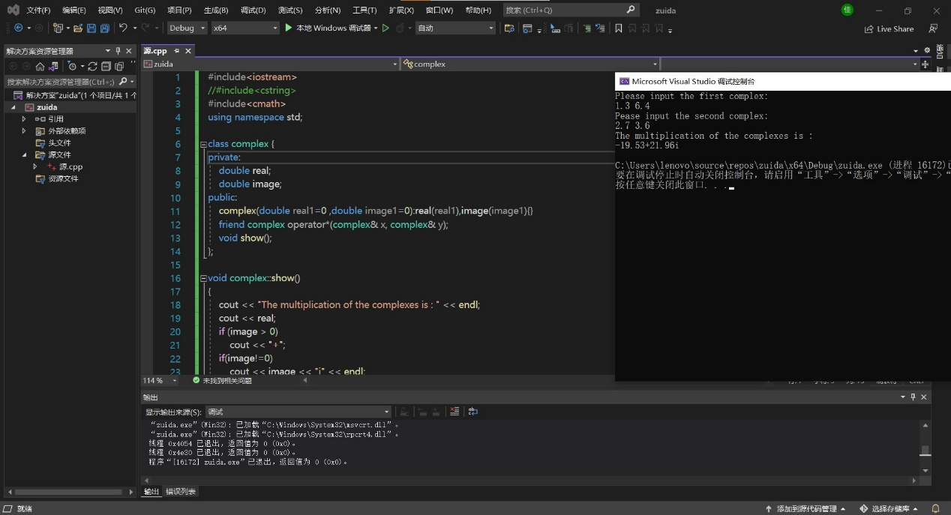

**实验心得**

这次试验是我编的比较得心应手的一次，感觉要爱上C++啦，虽然在这次编程过程中遇到了几个小问题，但是解决了真的很开心，一个是构造函数参数的问题，还有就是粗心的错误问题。

Copyright ©2021-2099 Yanshuo Zhang. All rights reserved